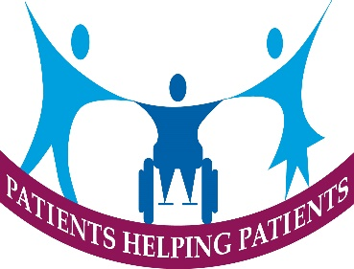
Notes of the Patient Participation Group Meeting
Tuesday 3rd October 2023 in the meeting Room Coach House
There were 12 members present and 7 apologies were received
Meeting
Concern was expressed by the members that the recent publicity regarding that independent Pharmacists were not being fully reimbursed in full by NHS for some high cost prescription drugs could mean the reduction in local pharmacists who were providing a vital community service. It was agreed that this should be raised with the ICB.
Visiting Speaker – Angela Bunn –Disability Solutions
It is 4 years since She gave a talk & Demonstration to the Members and the current talk outlined the work of the organisation in SoT post codes. They provide a social prescribing service for disabled people –Disability Connect, S, a pecialist equipment and aids advice, help with appeals and tribunals concerned with securing benefits for clients,.
They provide a joint service with MacMillan in delivery of a benefits service to patients and their families affected by cancer. The Stoke on Trent Benefits service and deliver Disability Awareness & Equality training to business organisations and local authorities.
Practice report
Many members had volunteered for the three Flu/Covid Vaccination Sessions on 23rd September and 14th and 19th October 2023. In addition to these sessions there would be appointments available during normal surgery hours for patients to book their personal Vaccination.
Patient Survey
Patient on line access support- the trail of support from U3A had been a limited success and the group were planning to develop appropriate support to meet the needs of patients concentrating on Patient Access with a target of offering such support in the first Quarter of 2024.
Future Questionnaires- any further development work was being postponed until it could be established what overriding questions may be required by ICB.
Next meeting – 10,00am Tuesday 7th November 2023 –St Luke’s Church.

